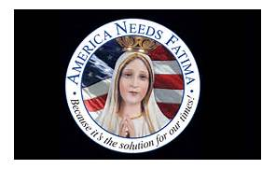
Public Rosary Gathering

Can we come together as a family to Pray the Rosary
in the Parking Lot at our St Leo’s Worship Site
2748 Military Road on
Saturday, October 14th at Noon

We are part of hopefully 20,000 groups that will
be doing that same thing….throughout America
Pray the Rosary in Public!!

